SCHEDULE OF UNIFORM & EQUIPMENT
Effective from September 2026

This schedule is designed to enable parents/carers to have a clear idea of the uniform requirement and how it is to be worn. Our pupils are ambassadors of Slindon College and must maintain a smart appearance when travelling to and from the College as well as during the school day.

JW Sports items are available from www.jwsports.net ‘School Wear’ section.

Uniform
Year 4 to 6 Uniform | Supplier
TANK TOP navy v-neck  JUMPER navy long sleeve v-neck (option) | NEXT ‘Navy School Tank Top’  M&S ‘Unisex Cotton Rich Jumper’
SHIRT white long sleeve  SHIRT white short sleeve (option) | Unspecified
TIE house colours available in two lengths | College
TROUSER charcoal grey  SHORTS charcoal grey (option) | Unspecified  Unspecified
SOCKS grey or black | Unspecified
SHOES black sensible and polishable | Unspecified
BOMBER JACKET navy fleece lined waterproof insulated with hood and College crest (either/or) | College
HAT navy beanie with College crest (optional) | College
RUCKSACK navy with College crest with boot compartment Blue, White Piping & Initials (either/or)  DRAWSTRING BAG navy with College crest (either/or) | JW Sports  College
Year 7 to 11 Uniform | Supplier
BLAZER navy with College crest | College
TANK TOP navy v-neck | NEXT ‘Navy School Tank Top’
SHIRT white long sleeve  SHIRT white short sleeve (option) | Unspecified
TIE house colours available in two lengths | College
TROUSER charcoal grey | Unspecified
SOCKS grey or black | Unspecified
SHOES black sensible and polishable | Unspecified
QUILTED JACKET navy diamond quilted showerproof with College crest (either/or)  BOMBER JACKET navy fleece lined waterproof insulated with hood and College crest (either/or) | College (adult sizes only)  College
HAT navy beanie with College crest (optional) | College
RUCKSACK navy with College crest with boot compartment Blue, White Piping & Initials (either/or)  DRAWSTRING BAG navy with College crest (either/or) | JW Sports  College

General Guidance
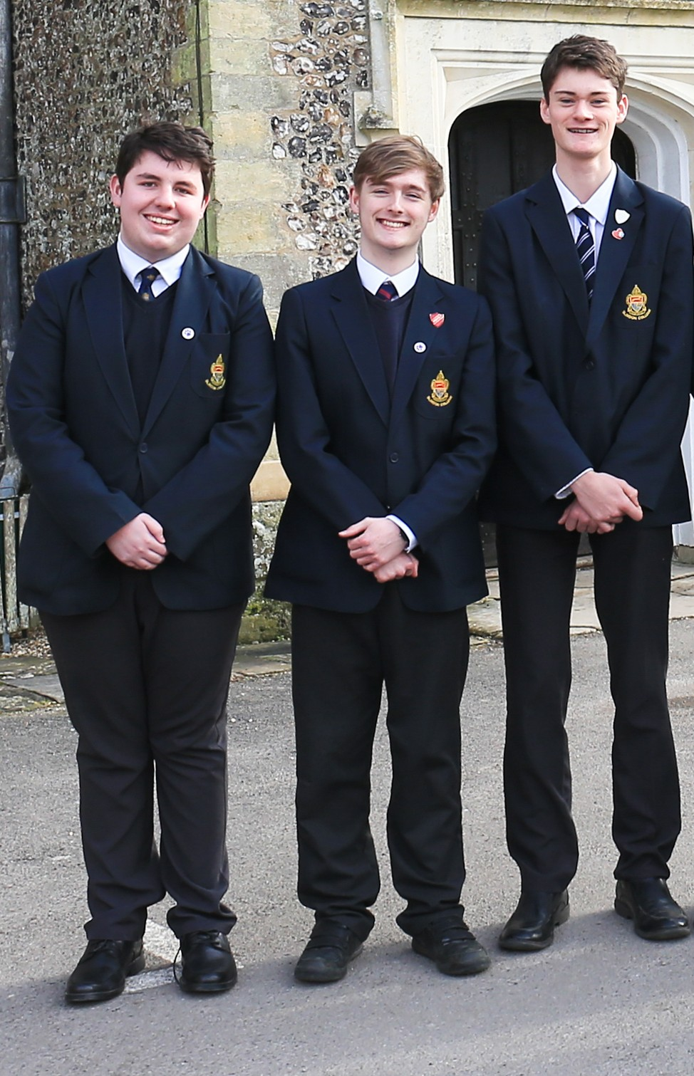
All items of clothing, bags and water bottles should be in a good state of repair and clearly marked with the pupil's name.

Shirt top buttons and ties are to be done up and shirts tucked in at all times.

Outdoor jackets may only be worn outside the buildings and are not permitted inside specifically in the classroom, dining room, during assembly or in Church. Non-uniform jackets are not permitted.

Hairstyles should not draw attention to the pupil. Styles must look natural and should not be dyed or bleached nor should bleaching products be used. Hair gel may be used in small amounts to maintain styles. Hair must be off the face and not shaved lower than grade 2. No adornments are to be worn nor symbols shaved in. Long hair must be tied back for the safety and hygiene of the pupil. Pupil facial hair must be neat and well-kept.

Apart from watches and approved religious wear, jewellery and piercings are not permitted. Transfer tattoos/body art are not permitted except for religious festivals. This is primarily for the safety in PE lessons, but also because loss or damage can cause distress.
The Headteacher reserves the right to make a final decision with regards to uniform, hairstyles, jewellery and so forth deemed to be unacceptable.
Games Uniform and Equipment
Games/PE Kit | Supplier
UNISEX POLO Navy, White Piping & Initials | JW Sports
MID LAYER Navy with Initials (not required for Year 4-6) | JW Sports
UNISEX SHORT Navy, White Piping & Initials | JW Sports
Tracksuit Bottoms SKINNY PANT Navy with Initials (either/or)  Tracksuit Bottoms TRACKSUIT PANT Navy with Initials (either/or) | JW Sports  JW Sports
SOCKS house colour | College
Sports Trainer SOCKS White (above ankle) | Unspecified
TRAINERS for outdoor games and play | Unspecified
FOOTBALL BOOTS rubber moulded studs | Unspecified
SHIN PADS | Unspecified
GUM SHIELD | Unspecified

Swimming Kit | Supplier
SANDALS flip-flop style (swimming pool use) | Unspecified
SWIMWEAR trunks/shorts (not below knee style) | Unspecified
TOWEL (swimming pool use) | Unspecified
PONCHO TOWEL (homemade or purchased) | Unspecified

Wash Kit | Supplier
TOWEL | Unspecified
Body/Hair SHOWERGEL | Unspecified
SPARE underwear and socks | Unspecified
DEODORANT (no aerosols permitted) | Unspecified

Outdoor Education | Supplier
Walking Boots or Sturdy Trainers | Unspecified
Waterproof Trouser (pac-a-mac style) | Unspecified
Waterproof Jacket (pac-a-mac style) | Unspecified
Outdoor Trousers or old home clothes willing to get dirty and damaged (not heavy cotton or jeans). | Unspecified
Outdoor Fleece or old home clothes willing to get dirty and damaged (not heavy cotton or jeans). | Unspecified
Outdoor T-shirt/Polo shirt or old home clothes willing to get dirty and damaged (not heavy cotton or jeans). | Unspecified
Outdoor Education lessons may include archery, mountain biking, orienteering and Forest School. The pupils will get wet and dirty and the expectation is the kit will go home weekly for washing and drying. Due to activities undertaken there is a risk of damage to kit.

Boarding
Other necessary items for boarders | Number
Large towels | 1
Washbag with usual toiletries (no aerosols permitted) | 1
Large suitcase clearly labelled on the outside | 1
Weekend bag suitable for overnight stays | 1
Underclothes (socks and pants) | 4 sets
Nightwear | 2 sets
Slippers | 1 pair
Dressing Gown/Towelling Robe | 1
Jeans, casual wear suitable for evenings | Multiple
Casual clothes are permitted at the end of the school day. These should be suitable for the active, outdoor life the pupils lead here. All boarders items of clothing must be labelled.

All machine-washable items will be laundered on-site for Weekly boarders for which a charge is made and added as a Supplementary Charge. All clothing must be suitable for commercial washing and tumble drying. Designer items and those requiring hand washing cannot be catered for and should not be brought to College.

For further assistance with uniform or boarding item requirements please contact the Matron matron@slindoncollege.co.uk.

For further assistance with Games Uniform & Equipment item requirements please contact the PE Department pedept@slindoncollege.co.uk.

